**DAILY ONLINE ACTIVITIES SUMMARY**

|  |  |  |  |  |  |  |  |  |
| --- | --- | --- | --- | --- | --- | --- | --- | --- |
| **Date:** | 18/05/2020 | | | | | **Name:** | Krishnitha | |
| **Sem & Sec** | IV sem, A section | | | | | **USN:** | 4AL18CS039 | |
| **Online Test Summary** | | | | | | | | |
| **Subject** | | Engineering Mathematics | | | | | | |
| **Max. Marks** | | 30 | | **Score** | | | NA | |
| **Certification Course Summary** | | | | | | | | |
| **Course** | AWS ALEXA | | | | | | | |
| **Certificate Provider** | | | AWS Educate | | **Duration** | | | 2hrs |
| **Coding Challenges** | | | | | | | | |
| **Problem Statement:** 1) Given an array of distinct integers. The task is to count all the triplets such that sum of two elements equals the third element.  **2)** Write a C Program to check whether the two string are Anagram or not. | | | | | | | | |
| **Status:** Executed | | | | | | | | |
| **Uploaded the report in Github** | | | | | yes | | | |
| **If yes Repository name** | | | | | <https://github.com/krishnitha/lockdown-coding/blob/master/triplet.c>  <https://github.com/krishnitha/lockdown-coding/blob/master/anagram.c> | | | |
| **Uploaded the report in slack** | | | | | yes | | | |

Online Test Details:

online test of engineering mathematics was conducted from 9:30-10:00am. Which included 30 questions of 1 mark each. Marks are not allocated till now.

Certification Course Details:

Today, I started **AWS ALEXA** certification course provided by AWS educate. As the part of **ICT ACEDEMY** Certification course. I completed Module 1: Prerequisite Knowledge consisting of two chapters named Prerequisite Knowledge - S3 and [Prerequisite Knowledge - Lambda](https://awseducate.instructure.com/courses/175/modules/items/3947).

Chapter 1 consists some fundamental prerequisite knowledge which is foundation for requisite technical knowledge.

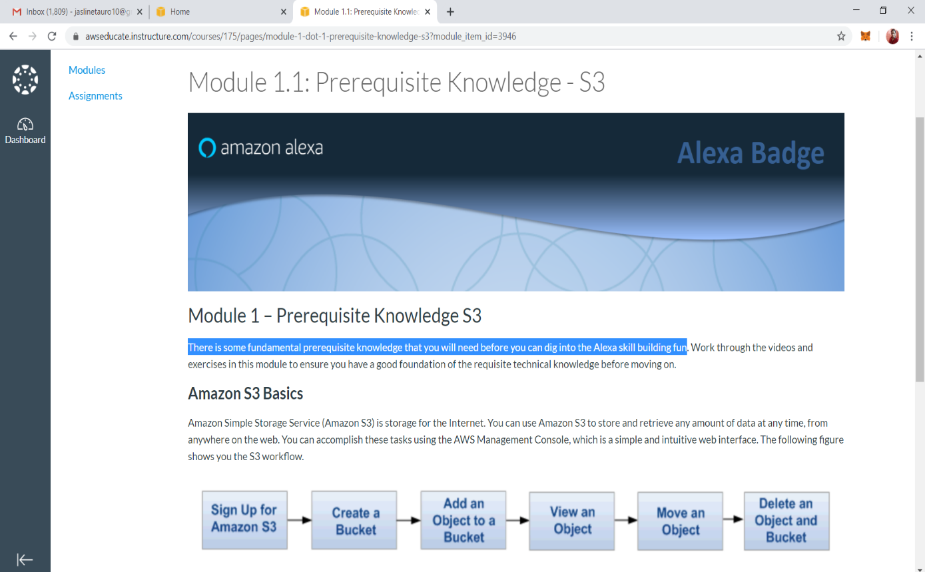

## And second chapter consists of some fundamental prerequisite knowledge about lambda

## 

Coding Challenges Details:

Problem 1: Given an array of distinct integers. The task is to count all the triplets such that sum of two elements equals the third element.

**Input:**  
The first line of input contains an integer **T** denoting the number of test cases. Then T test cases follow. Each test case consists of two lines. First line of each test case contains an Integer **N** denoting size of array and the second line contains N space separated elements.

**Output:**  
For each test case, print the count of all triplets, in new line. If no such triplets can form, print "**-1**".

**Constraints:**  
1 <= T <= 100  
3 <= N <= 105  
1 <= A[i] <= 106

**Example:  
Input:**  
2  
4  
1 5 3 2  
3  
3 2 7  
**Output:**  
2  
-1

**Explanation:  
Testcase 1:** There are 2 triplets: 1 + 2 = 3 and 3 +2 = 5

Solution: Uploaded in GitHub.

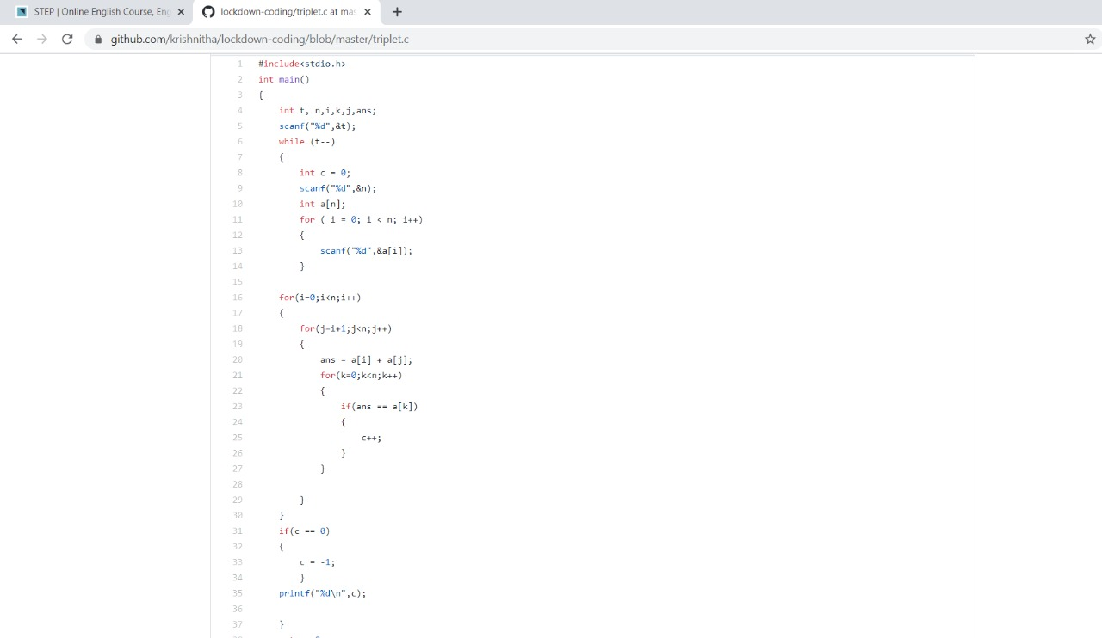

Problem 2: Write a C Program to check whether the two string are Anagram or not.

Hint: An Anagram of a string is another string that contains same characters, only the order of characters can be different.

For example, "act" and "cat" are anagram of each other.

**Solution:** Uploaded in GitHub.

